|  |
| --- |
| **Argentis Consulting** |
| **Apparel & Footwear** |
| SHIPMENT MANAGEMENT |



**www.sapapparel.com**

Table of Contents

1 Apparel & Footwear – Shipment and Container Management Solution 3

1.1 Objectives 4

1.2 Setup 4

1.3 Shipment Plan Procedure 6

1.4 Manual Container Create/Update 8

1.4.1 Creating Packing Slips 11

1.4.2 Create Delivery 12

1.5 Auto Create Container / Packaging Wizard 13

1.5.1 Default Package by Style 14

1.5.2 The Wizard 14

# Apparel & Footwear – Shipment and Container Management Solution

Containers are part of the logistic module in SAP Business One and stand between Purchase Orders/Sales Order and Goods Receipts/Deliveries. The concept is to allocate Purchase Order (buyer) & Sales Order (supplier) lines to entire shipments or containers. Also the ability to estimate dates of shipments, arrivals as well the creation of receipts to finally apply landed cost in SAP B1.



The user creates a shipment plan holding multiples containers and packing slips by container.



## Objectives

1. To Plan, control, settle and analyze the shipment/container lifecycle

2. Detail picture for container inventory an costs

3. Integrate with PO/SO. Allow to allocate different PO/SO lines to container – shipments

4. Integrated packing module. Be able to pack items in the container.

5. Integrate with GRPO. Receipts total or partial shipments-container to final warehouse destination.

6. Integrate with delivery process. Generate Delivery documents from container.

7. Integrate with Landed Cost. Apply standard landed cost concepts to entire shipment.

8. Track Status of containers via multiples reports (By item, vendor, shipment manifest, packing slip etc.)

## Setup

Please go to following path to create all Containers master data.

Apparel and Footwear 🡪Administration →Shipment Management →Container Master

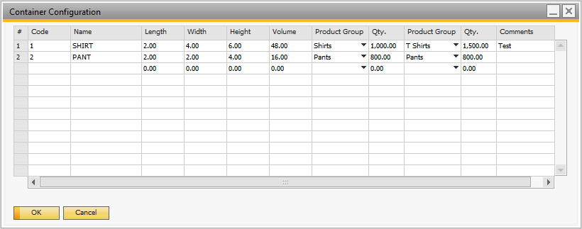

Creates Port of Entry

Apparel and Footwear 🡪Administration →Shipment Management →Port of Entry

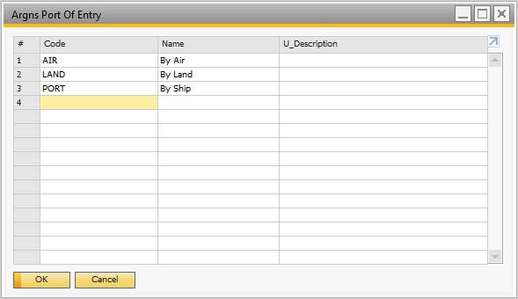

## Shipment Plan Procedure

To create a new shipment plan go to Shipment Management →Shipments and Containers.

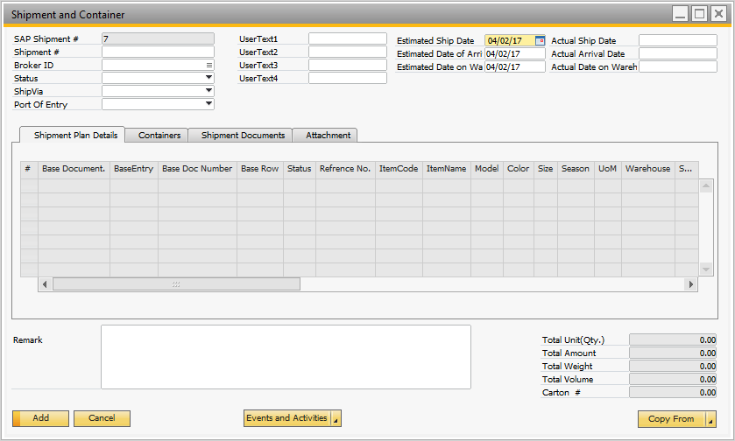

Select the option to copy:

1. Sales orders. If this is an outgoing shipment / container.

2. Purchase Order. For incoming shipments / containers

Once the shipment plan is saved it cannot combine sales with purchase order types.

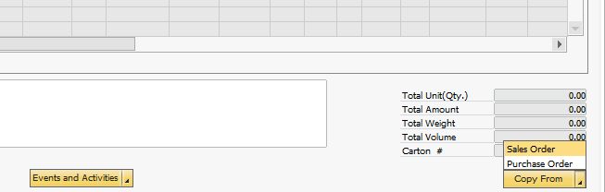

3. Multiple Sales Order/Purchase Order also can be selected.

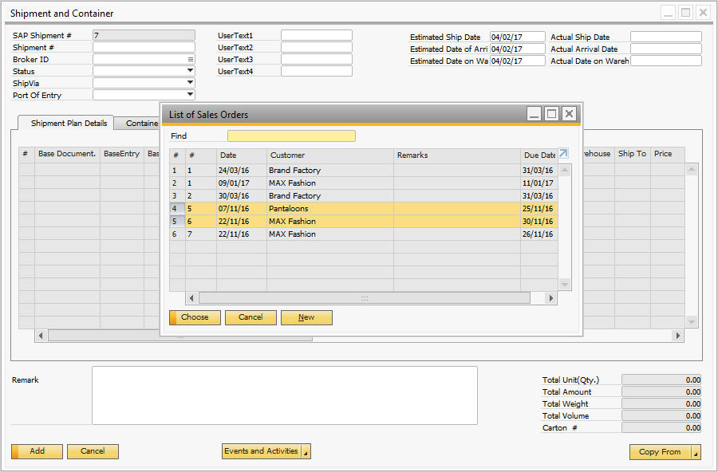

4. Select the lines from the orders that will be included in the shipment plan.

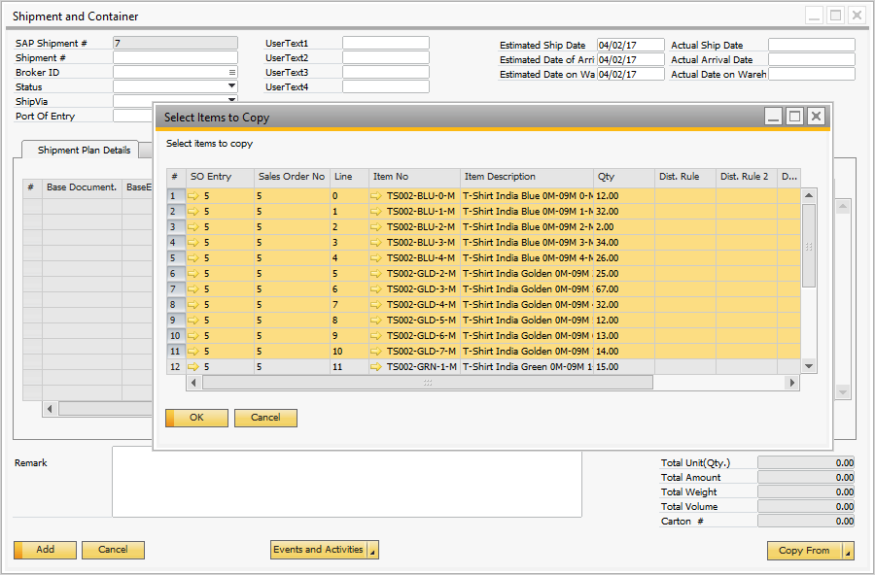

5. Add the shipment plan.

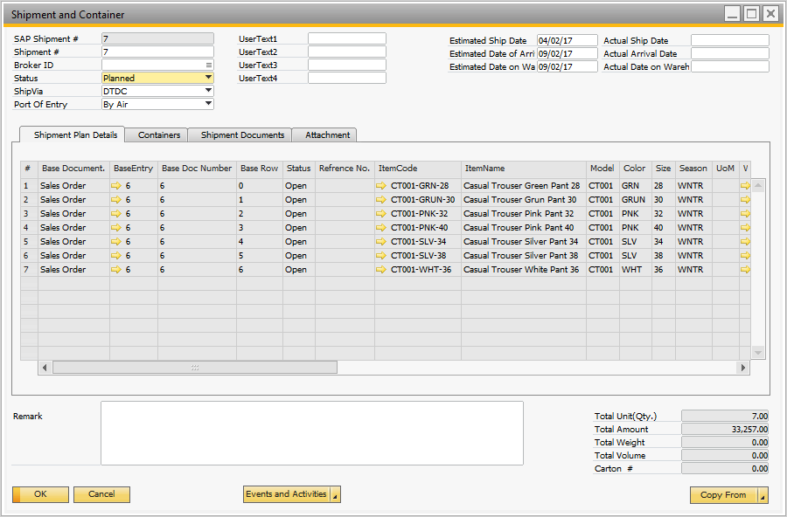

## Manual Container Create/Update

1. The shipment plan can be shared with business partners. Once the production is ready, create the containers. Right click in the shipment plan and select the option Create / Update Containers.

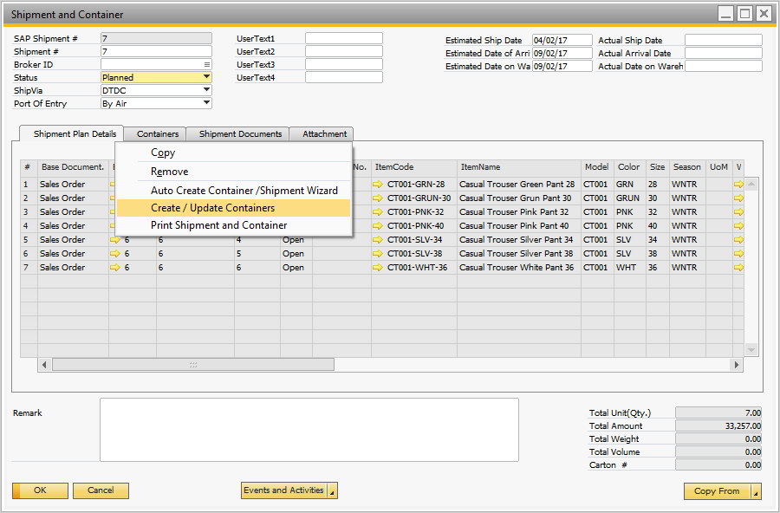

2. Select a container type, select the available lines in the shipment plan and add to the container.

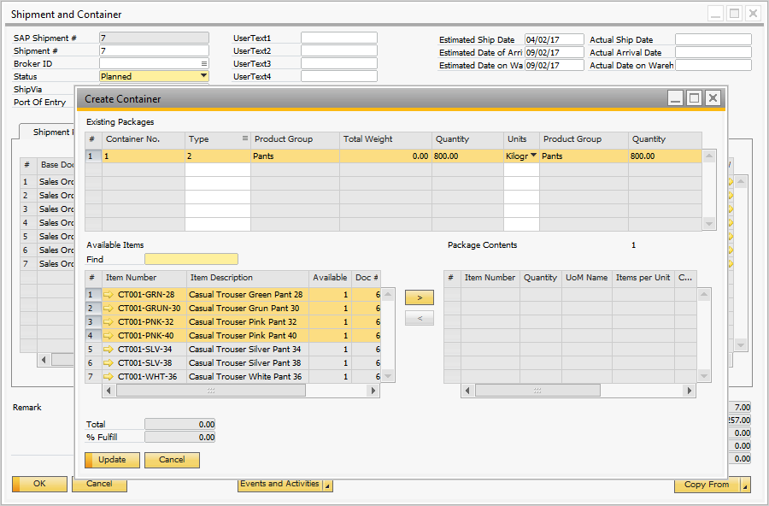

3. If there is more than one container then add a new row and repeat the process with the available lines.

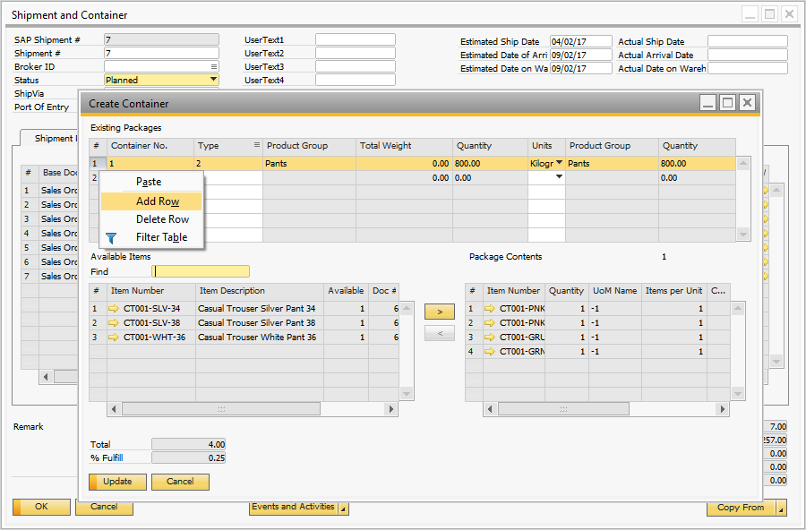

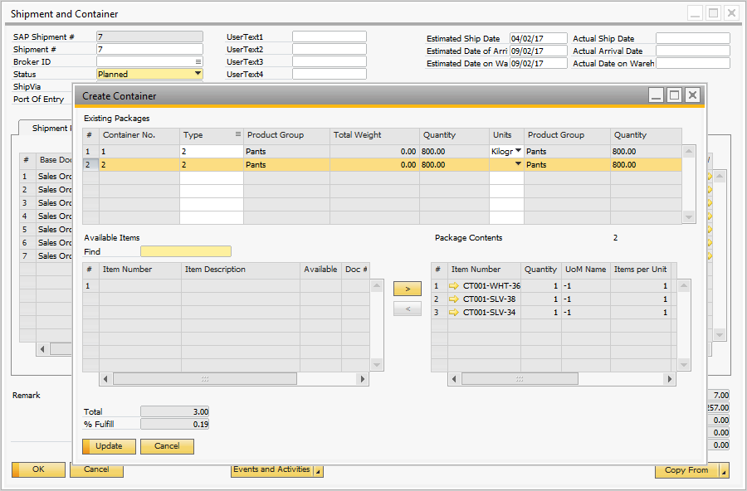

4. In the container TAB the user can review the containers with the content.

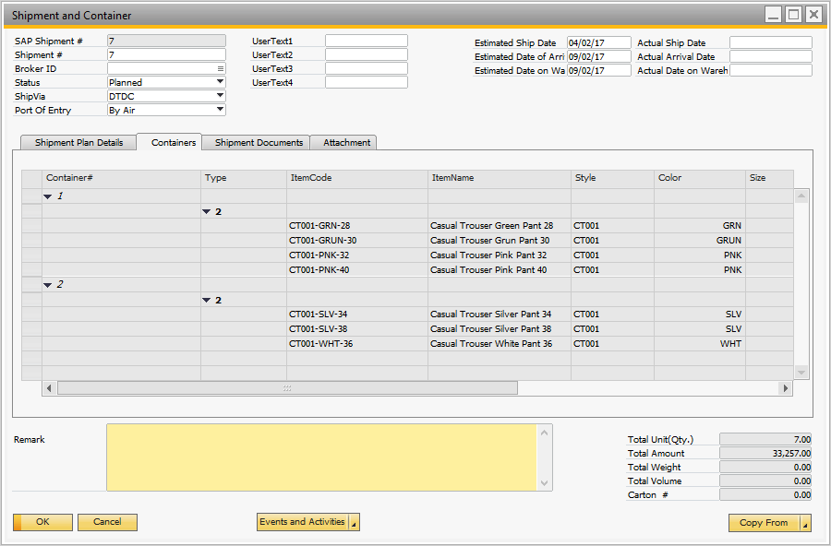

### Creating Packing Slips

1. Once the container is ready, the user can add the packing list information by right click on the container list and select Packing list.

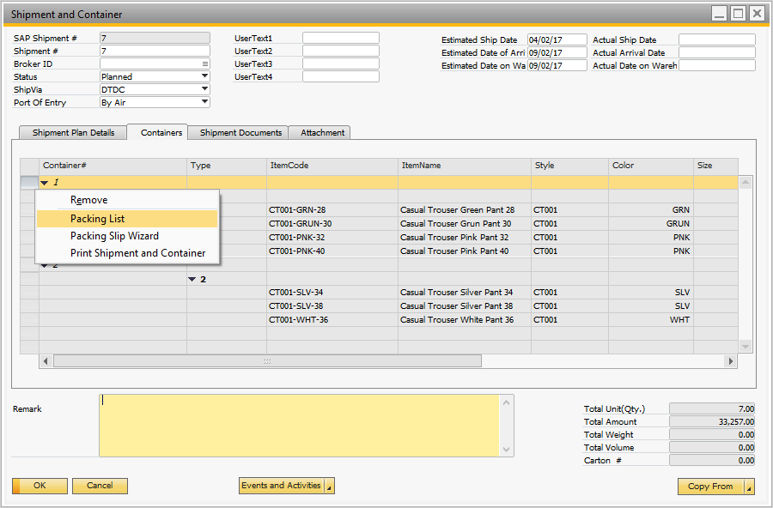

2. Select a package type and add the items to the package.

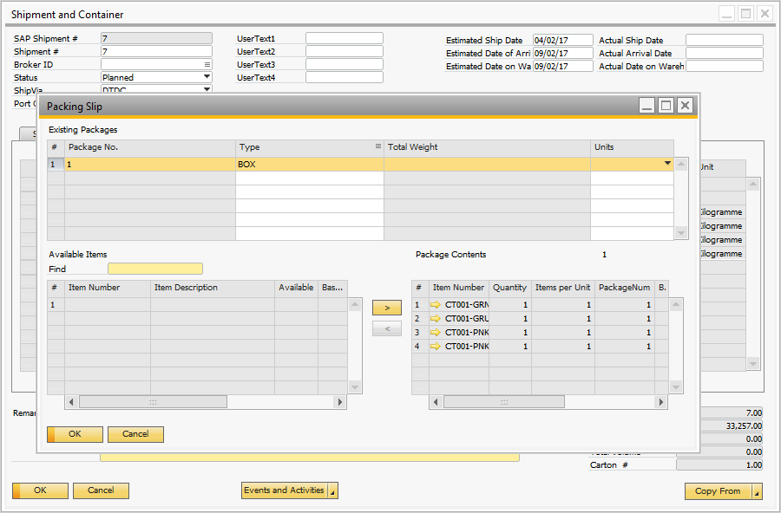

3. Print Container / Packing Slip

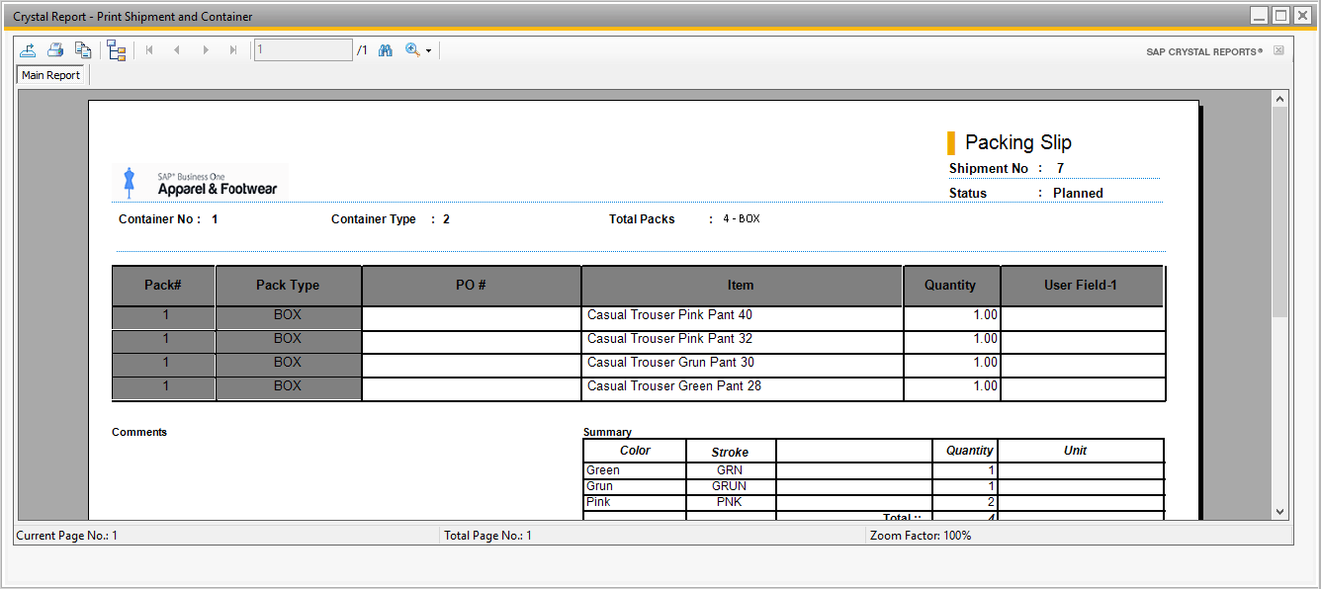

### Create Delivery

1. To create the Delivery Note, right click on the shipment and container form and click on the option “Create/Update Containers”.

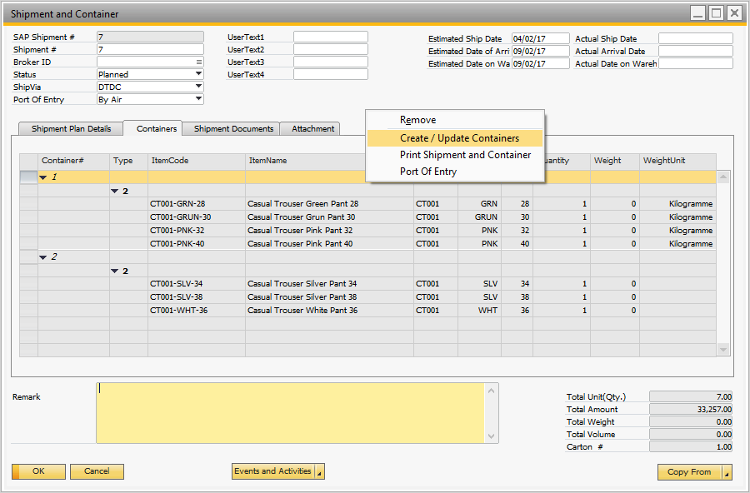

2. Right click on the 1st container and click on the option “Create Delivery notes”.

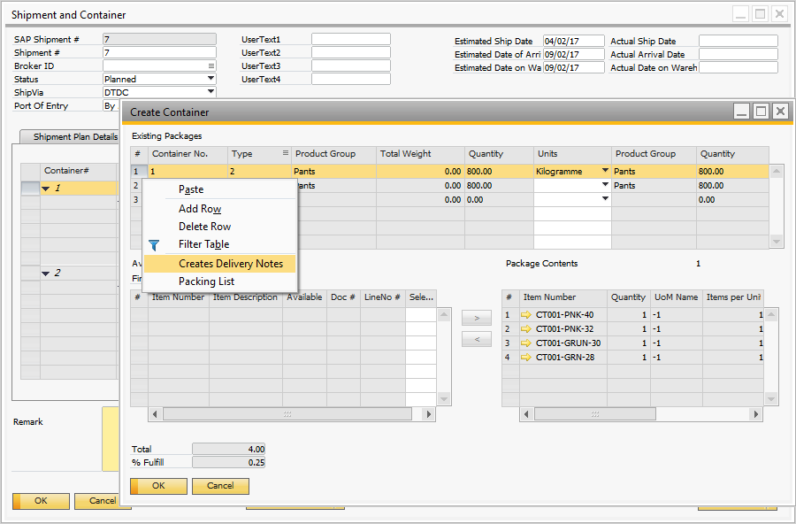

## Auto Create Container / Packaging Wizard

Containers can be filled by different type of garments or products. For each container record specify the quantities based on style group. For example a SHIRT container can hold up to 1500 T-shirts and other type of products. This is the total column. Also there might be other containers that are setup with bars to ship PANTS.

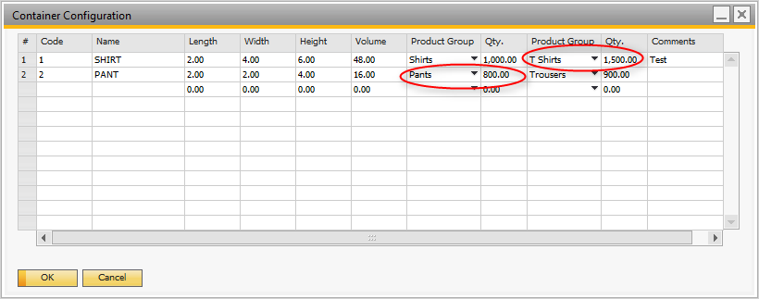

### Default Package by Style

In order to create the packing slips, link a package type to the style. This will be used to pack the items automatically. If this information is not set the user will have to add the items to packages individually.

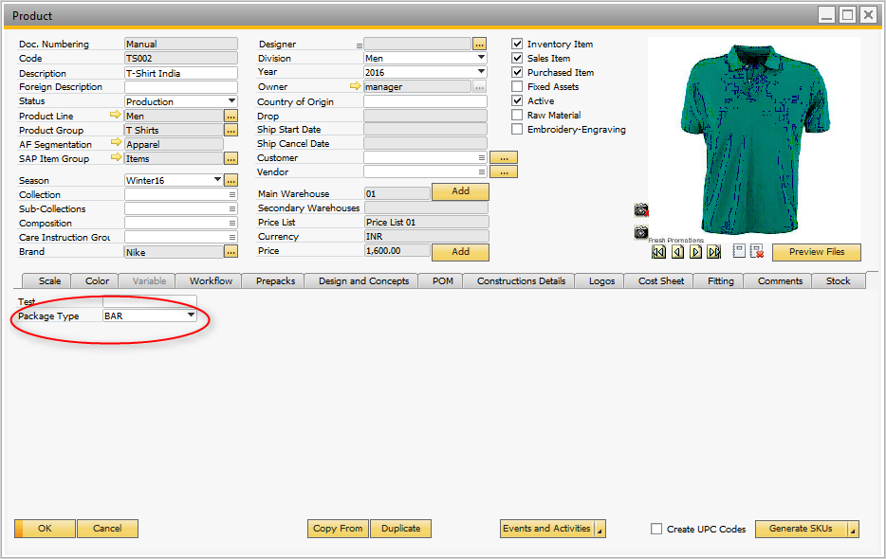

### The Wizard

1. First create a shipment plan with sales orders, the right click on the form and click on “Auto create Containers/Shipment Wizard”

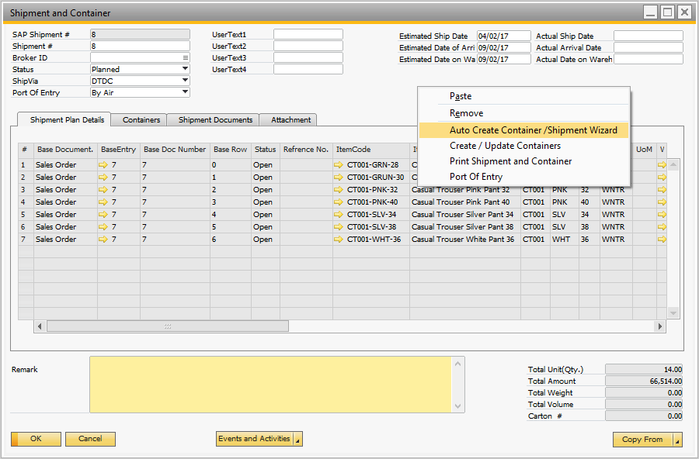

2. Select the customer which you want to create the container.

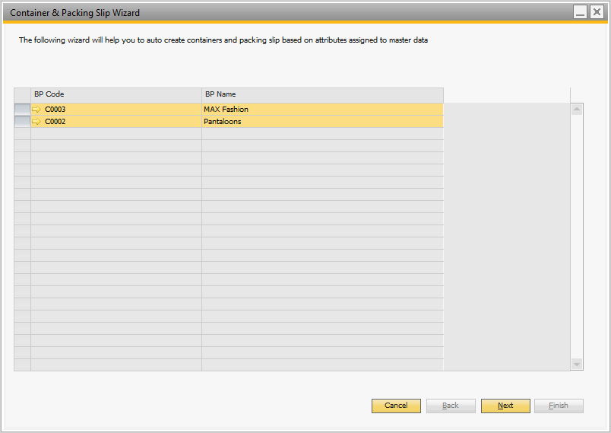

3. Select the order of the customer

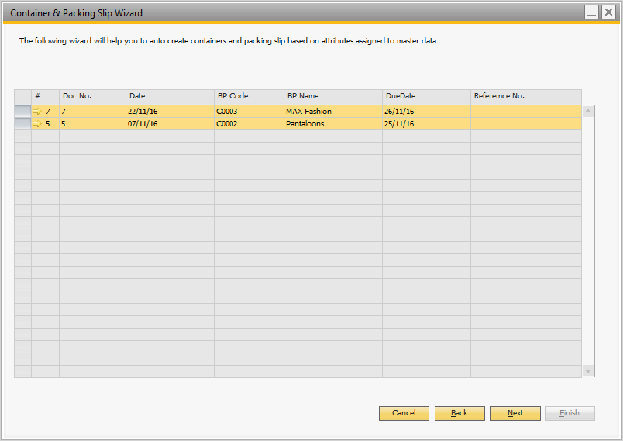

4. Select the lines to be included in the containers. The wizard recommends based on Loading port (warehouse) and ship to address. Order lines coming from different sources cannot be in the same container or have mixed ship to addresses.

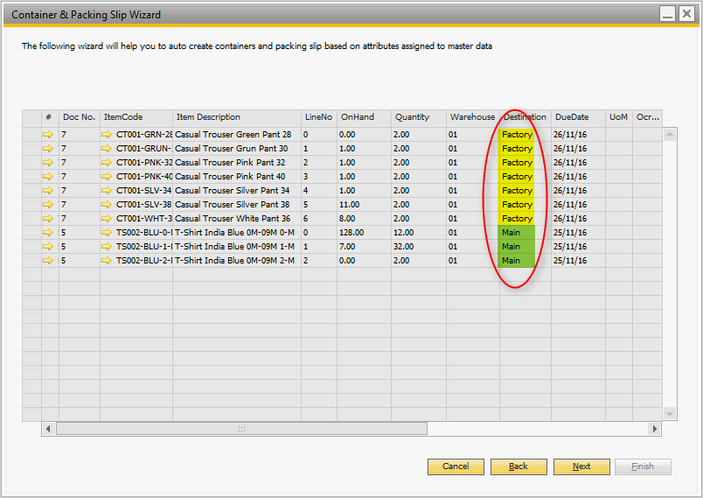

5. The wizard creates the container/s showing the % of container fulfilment.

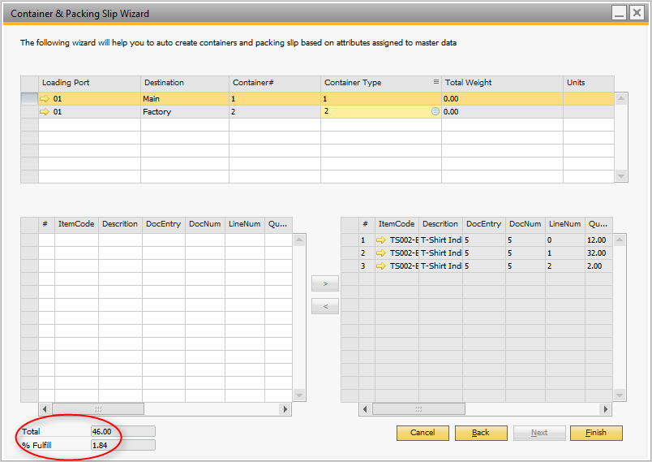

6. Each style has a default package. The wizard will propose to pack the items in the default package (the user can change the package by line). After the wizard creates all packages the content can be amended manually.

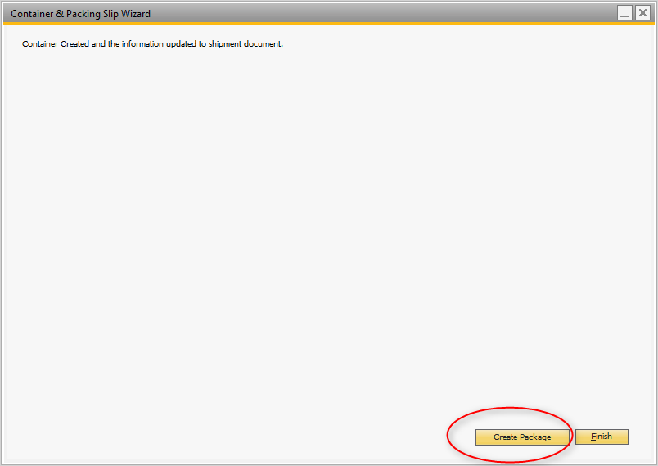

7. Now the user can run the auto-packaging wizard running the following logic:

1. Standard: packages are created with items by order line. If the package is a BOX with 10 items and the order has 200 items it will create 20 packages of 10 regarding color, sizes or size run.
2. Model Color: the boxes are grouped by style-color, making sure that colors are not mixed in boxes.
3. Model Scale: the boxes are created with items with same size codes.

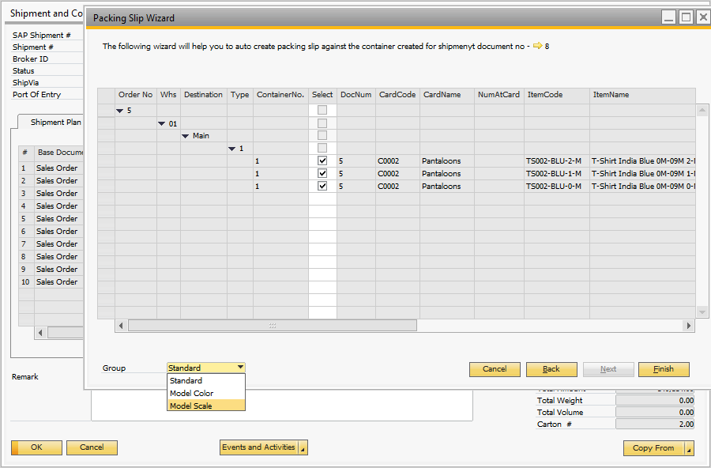



**www.argentisconsulting.com**

**Argentis Consulting** is dedicated to the development, distribution and support of recognized certified solutions for SAP Business One, as an SSP (Software Solution Provider) with a Gold Partner status.

**CONTACT INFORMATION**

|  |  |
| --- | --- |
| **USA**  9744 NW 45th Lane  Doral, FL 33178  info@argentisconsulting.com | **ARGENTINA**  Ávila y Zarate 2048  Cerro de la Rosas, Córdoba,  CP 5009  Córdoba - Argentina  info@argentisconsulting.com |
| **CARIBEAN**  City View Plaza – Suite 301  48 Road 165  Guaynabo, PR. 00968  Puerto Rico  caribe@argentisconsulting.com | **SPAIN**  C/ Juan Bravo N° 3 A 28006  Phone: (+34) 91 123 7263  Madrid - Spain  info@argentisconsulting.com |